**TASK 5**

**Name:** THESEGA P S

**Rollno:** 22CSR224

**Step 1:** Create a directory and navigate to the directory and install the git package using the following command:

mkdir pet

cd pet

apt install git

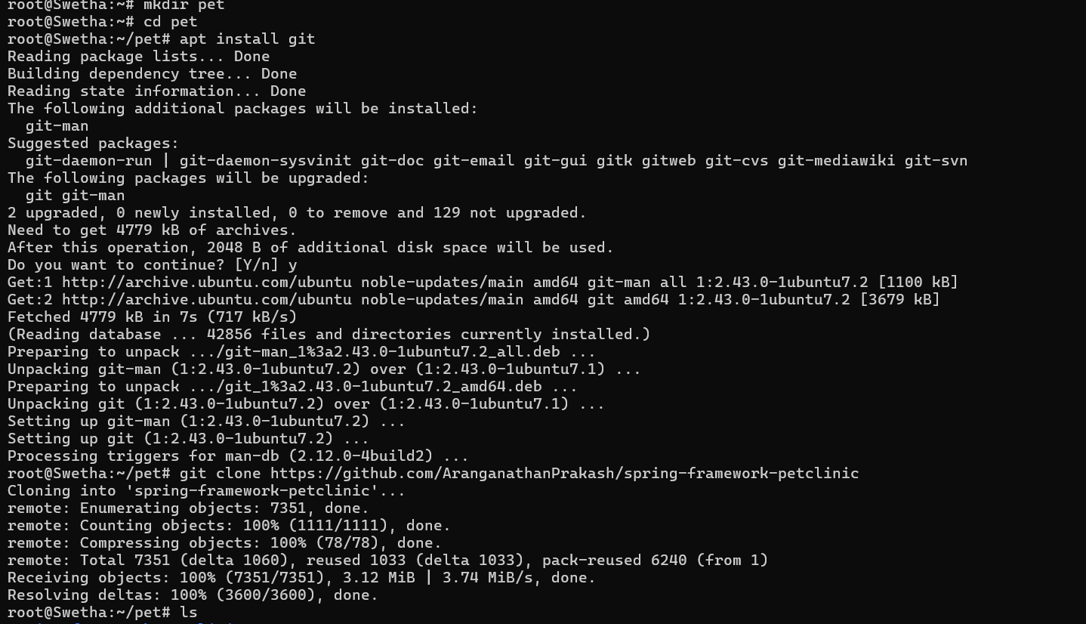

**Step 2:** By using the ls command check whether the required directory is exist or not



**Step 3:** Move to the directory and give ls command to check the file exist****

**Step 4:** Install the maven package using the command:

install maven

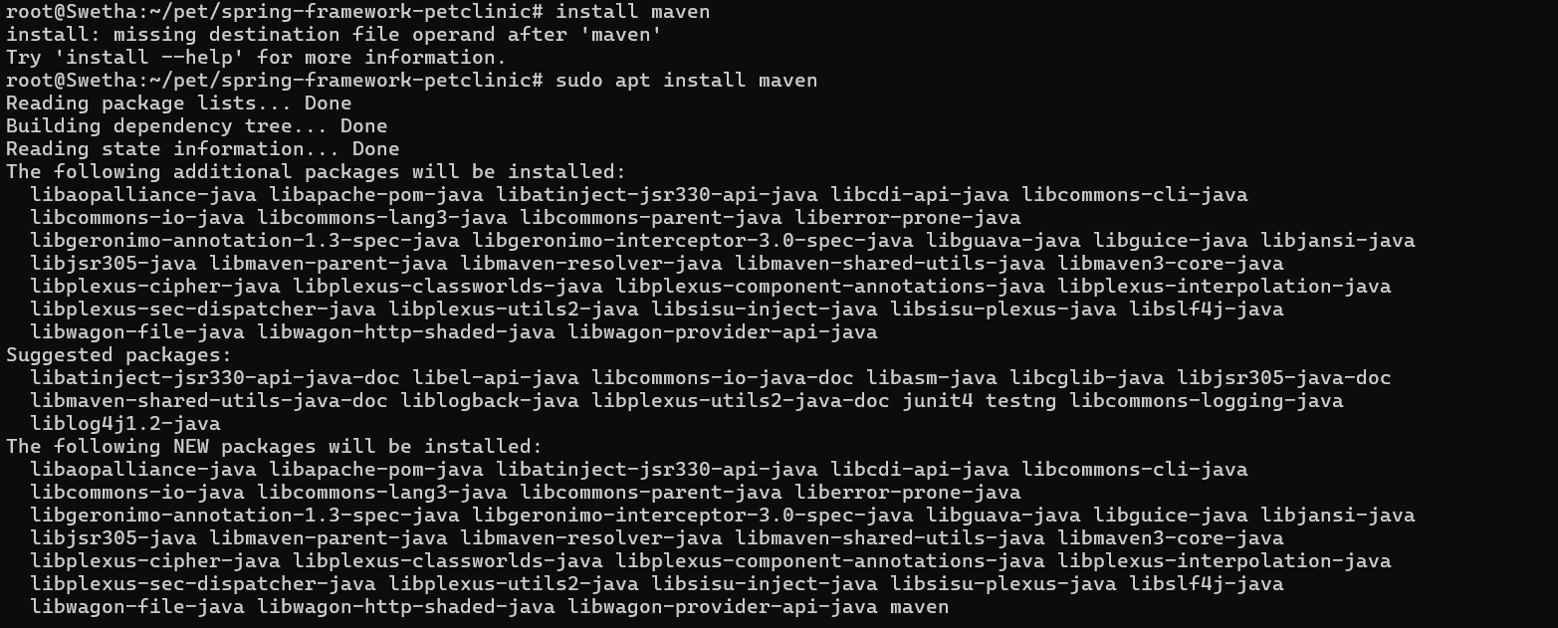

**Step 5:** Clean the maven packages using the command:

mvn clean

